实验6 无线健康监测开放实验

1.搭建MQTT代理
Mosquitto是一个开源（EPL/EDL许可）的消息代理，实现了MQTT协议5.0、3.1.1和3.1版本，由Roger Light于2009年开发并捐赠给Eclipse基金会。Mosquito轻量级特性使其适用于从低功耗单板计算机到全服务器的所有设备。本节实验将展示在Windows 11系统中搭建基于Mosquitto的MQTT代理，具体步骤如下：
⑴从Mosquitto官网（https://mosquitto.org/download/）下载Windows系统的安装包（https://mosquitto.org/files/binary/win64/mosquitto-2.0.19-install-windows-x64.exe）；
⑵双击下载的应用（mosquitto-2.0.19-install-windows-x64.exe）开始安装，系统会提示安全问题，直接选择“仍然运行”即可。图1是安装过程。
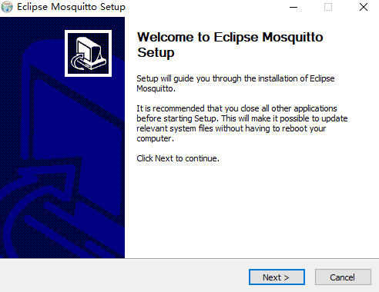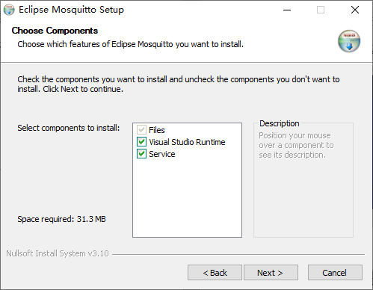
(a)开始安装 (b)选择组件
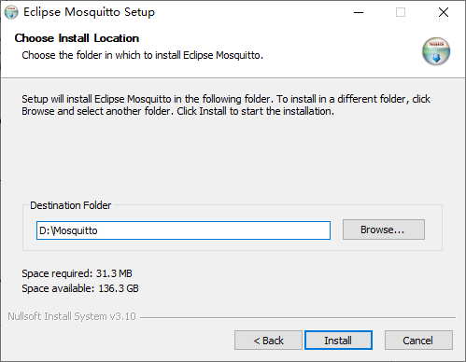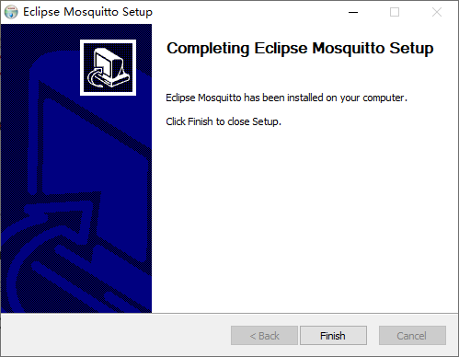
(c)选择安装位置 (d)完成安装
图1 Mosquitto安装过程
⑶配置Mosquitto代理（安装路径为“D:\Mosquitto”，请根据实际安装位置替换）：利用记事本打开D:\Mosquitto中的配置文件mosquitto.conf，删除“#listener”的“#”并添加端口号1883。此外，为便于实验，设置允许匿名登录，将“#allow_anonymous false”修改为“allow_anonymous true”。下述加粗部分为修改的配置。
……
# listener 0 /tmp/mosquitto.sock
#
# listener port-number [ip address/host name/unix socket path]
listener 1883
……
allow_anonymous true
……
⑷启动Mosquitto代理：使用管理员身份打开命令行终端，在命令行中执行“cd D:\Mosquitto”进入Mosquitto安装目录，运行“mosquitto.exe -c mosquitto.conf -v”即可启动Mosquitto代理，如图2所示。
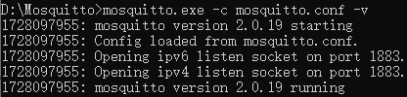
图2 Mosquitto代理成功启动

2.连接ESP32和传感器
本实验需将MAX30102传感器连接至ESP32开发板。图3是传感器与ESP32的连接示意图。
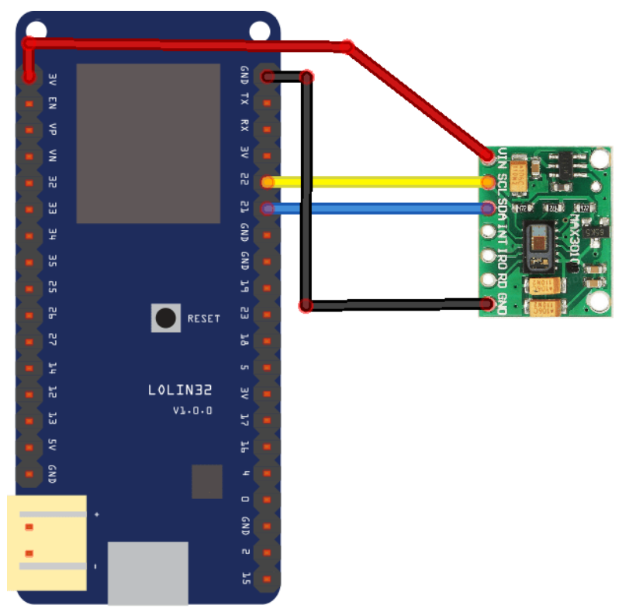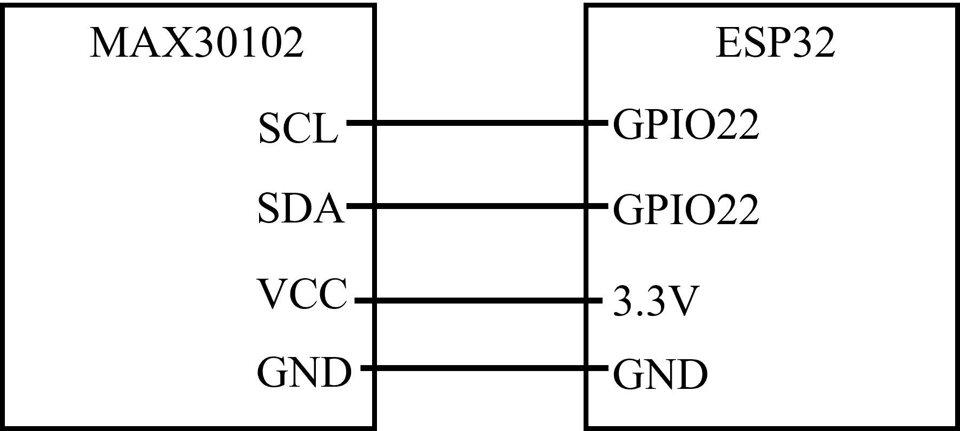
(a)实物链接图 (b)引脚接线图
图3 MAX30102与ESP32连接示意图

3.代码烧录与测试
在开始编译和烧录代码前，Arduino软件中增加ESP32开发板和传感器（MAX30102）的支持库。具体如下：
①打开Arduino IDE软件，选择“File->Preferences”，会出现如下窗口。
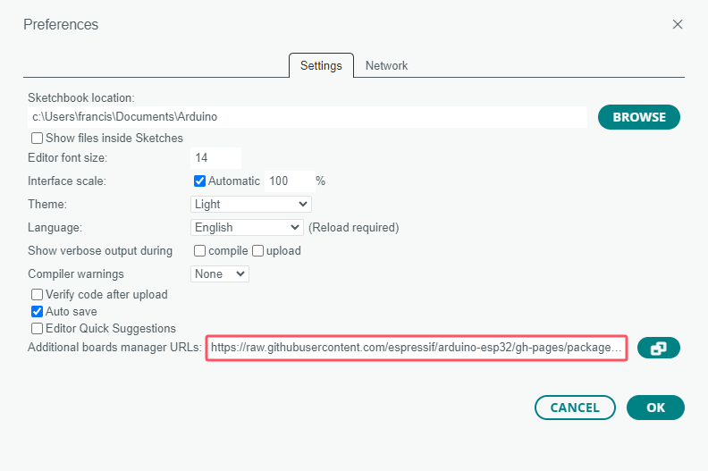
图4 添加ESP32开发板URL
在“Additional Board Manager URLs”的红框部分添加“https://raw.githubusercontent.com/espressif/arduino-esp32/gh-pages/package_esp32_index.json”，然后点击“OK”按钮，Arduino会自动下载安装ESP32开发板支持库。
②选择“Tools->Manage Libraries…”，会在Arduino软件左侧显示“Library Manager”窗口，在搜索栏中输入“MAX3010x”会出现MAX30102传感器库的安装信息，单击“INSTALL”即可开始安装。
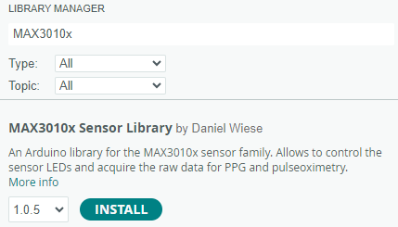
图5 MAX30102库安装
完成依赖/支持库安装后，即可开始编写、编译、烧录ESP32开发板代码。以下是ESP32参考代码：
#include <Wire.h>
#include "MAX30105.h"
#include "spo2_algorithm.h"
#include <WiFi.h>
#include <PubSubClient.h>
const char* ssid = "wiotlab"; // 连接WiFi名称（根据实际情况进行替换）
const char* passphrase = "12345678"; // 连接WiFi的密码
//MQTT代理设置
const char* mqtt_broker = "192.168.137.67"; // 本地电脑的IP地址
const char* mqtt_topic = "max30102"; // 自定义的MQTT主题
const int mqtt_port = 1883; // MQTT端口
WiFiClient espClient;
PubSubClient mqtt_client(espClient);
MAX30105 particleSensor;
#define MAX_BRIGHTNESS 255
byte pulseLED = 11;
byte readLED = 13;
#if defined(__AVR_ATmega328P__) || defined(__AVR_ATmega168__)
uint16_t irBuffer[100];
uint16_t redBuffer[100];
#else
uint32_t irBuffer[100];
uint32_t redBuffer[100];
#endif

int32_t bufferLength;
int32_t spo2;
int8_t validSPO2;
int32_t heartRate;
int8_t validHeartRate;
void connectToMQTT() {
while (!mqtt_client.connected()) {
String client_id = "esp32-client-";
client_id += String(WiFi.macAddress());
Serial.printf("Connecting to MQTT broker with client ID: %s\n", client_id.c_str());
if (mqtt_client.connect(client_id.c_str())) {
Serial.println("Connected to MQTT broker");
} else {
Serial.print("Failed with state ");
Serial.print(mqtt_client.state());
delay(2000);
}
}
}
void setup() {
Serial.begin(115200);
WiFi.begin(ssid, passphrase);
if (!particleSensor.begin(Wire, I2C_SPEED_FAST)) {
Serial.println(F("MAX30102 was not found. Please check wiring/power."));
while (1);
}
Serial.println(F("Starting data collection..."));
byte ledBrightness = 60;
byte sampleAverage = 4;
byte ledMode = 2;
byte sampleRate = 100;
int pulseWidth = 411;
int adcRange = 4096;
particleSensor.setup(ledBrightness, sampleAverage, ledMode, sampleRate, pulseWidth, adcRange);
while (WiFi.status() != WL_CONNECTED) {
delay(500);
Serial.print(".");
}
Serial.println("\nWiFi connected.");
Serial.print("IP address: ");
Serial.println(WiFi.localIP());
mqtt_client.setServer(mqtt_broker, mqtt_port);
mqtt_client.setKeepAlive(60);
connectToMQTT();
}
void loop() {
bufferLength = 100;
for (byte i = 0; i < bufferLength; i++) {
while (particleSensor.available() == false)
particleSensor.check();
redBuffer[i] = particleSensor.getRed();
irBuffer[i] = particleSensor.getIR();
particleSensor.nextSample();
}
maxim_heart_rate_and_oxygen_saturation(irBuffer, bufferLength, redBuffer, &spo2, &validSPO2, &heartRate, &validHeartRate);
while (1) {
for (byte i = 25; i < 100; i++) {
redBuffer[i - 25] = redBuffer[i];
irBuffer[i - 25] = irBuffer[i];
}
for (byte i = 75; i < 100; i++) {
while (particleSensor.available() == false)
particleSensor.check();
digitalWrite(readLED, !digitalRead(readLED));
redBuffer[i] = particleSensor.getRed();
irBuffer[i] = particleSensor.getIR();
particleSensor.nextSample();
if (spo2 <= 100 && spo2 > 0){
Serial.print(F(", HR="));
Serial.print(heartRate);
Serial.print(F(", SPO2="));
Serial.println(spo2);
if (mqtt_client.connected()) {
String payload = "";
payload += String(heartRate);
payload += ",";
payload += String(spo2);
mqtt_client.publish(mqtt_topic, payload.c_str());
}
mqtt_client.loop();
}
}
maxim_heart_rate_and_oxygen_saturation(irBuffer, bufferLength, redBuffer, &spo2, &validSPO2, &heartRate, &validHeartRate);
}
}
打开Arduino IDE软件，选择“File->New Sketch”创建Arduino项目，输入上述②的代码并按“Ctrl+S”保存代码（保存位置和名字可根据实际情况选择）。选择开发板“Tools->Board->esp32->ESP32 Dev Module”，点击进行代码验证，若代码无误则在Output窗口会出现“. Code in flash (default, ICACHE_FLASH_ATTR)”等提示信息。利用USB线连接另外一块ESP32开发板和计算机USB口，Arduino软件选择端口（Tools->Port）。串口正常选择后，单击烧录代码至ESP32开发板。

上位机代码请自行设计完成，可参考：
import paho.mqtt.client
import time
mqtt = paho.mqtt.client
def on_connect(client, userdata, flags, rc):
print("Connected with result code "+str(rc)) #打印连接状态
client.subscribe("2222") #订阅2222
def on_message(client, userdata, msg):
print(msg.topic+" " + ":" + str(msg.payload)) #打印接受的消息
client_id = time.strftime('%Y%m%d%H%M%S',time.localtime(time.time()))
client = mqtt.Client(client_id) # ClientId不能重复，所以使用当前时间
client.username_pw_set("test", "11223344") # 必须设置，否则会返回
client.on_connect = on_connect
client.on_message = on_message
client.connect("mnifdv.cn", 1883, 60)
client.loop_forever()

